School Participatory Budgeting Program (SPB Club)
Dear Parents/Guardians,

I am inviting your child ___________________________ to join this SPB after school club!

This year, <SCHOOLNAME> is participating in a School Participatory Budgeting initiative with support from the Center for the Future of Arizona (CFA) and Arizona State University’s Participatory Governance Initiative (ASU PGI). What students will be doing is deciding how to spend $<BUDGET> on a project to better improve our school community. Examples of this in previous years have been painting a mural for the school, building benches, buying a vending machine (with appropriate snacks/drinks), etc.

Along with myself, students will collect and brainstorm ideas, develop project proposals for approval by the school/district, and then vote for one of the ideas to be implemented on our campus!

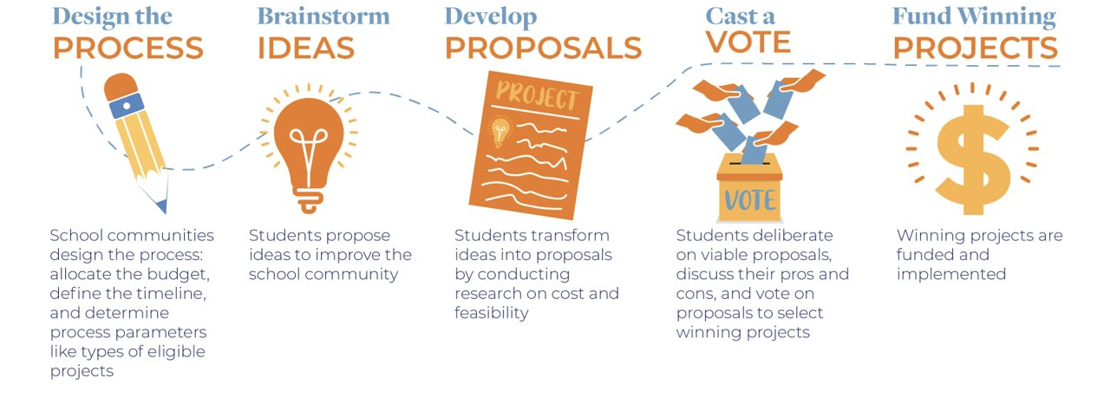
The dates are as follows:
<MONTHS FOR MEETING> Ex. October – March

<DAYS FOR MEETING> Ex. Mondays & SOMETIMES Fridays

<MEETING TIME> Ex. 3:15-4:15 p.m.

<SPECIAL MEETING NOTICES> Ex. Monday meetings will always take place unless school is out for a special holiday. For our Friday meetings students will know a week in advance if they have a Friday meeting and will take a note home as a reminder.

<TRANSPORTATION INFORMATION, especially if after or before school> Ex. Unfortunately, our club doesn’t have a bus available, and your child will have to be picked up at 4:15pm.

If you have any questions or concerns, please feel free to call or message me at:
<CONTACT INFORMATION>

Best,
<SPONSOR NAME>
RESOURCE SUBMITTED BY ADELINA ALMANZA, SPB SPONSOR IN ROOSEVELT SCHOOL DISTRICT

